Lab Assignment # 1

Name of Student : MANOJ
Enrollment No. : 2303A51524
Batch No. : 22

Task 1: AI-Generated Logic Without Modularization (Factorial without
Functions)

Prompt:-
Generate a clear and simple Python function that takes a list of IoT sensor readings and returns a new list containing only valid (zero or positive) values, without altering the original list.
Code:-
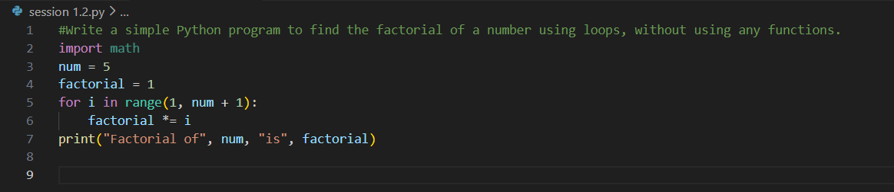

Output:-

Justification:-
This code solves the problem in a very straightforward way by writing everything in one place. It is easy for beginners to understand and good for small tasks. However, since it does not use functions, the code cannot be reused easily in bigger programs.

Task 2: AI Code Optimization & Cleanup (Improving Efficiency)

Prompt:-
Create an easy-to-understand Python function that analyzes a given string and reports the total number of vowels, consonants, and numeric digits, ignoring letter case.

Code:-

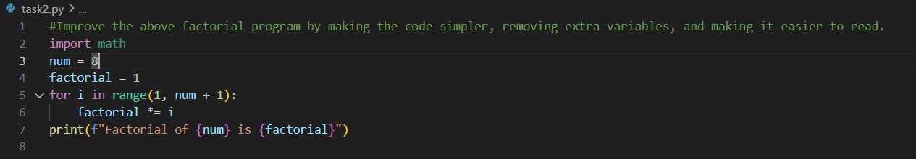

Output:-

Justification:-

This improved version looks cleaner and more organized. It removes unnecessary parts and focuses only on what is needed. Such clean code is easier to understand, debug, and maintain, especially when working with others.

Task 3: Modular Design Using AI Assistance (Factorial with Functions)

Prompt:-
Develop a beginner-friendly Python function that checks whether a given text is a palindrome by ignoring spaces and case differences, and returns a Boolean result..
Code:-
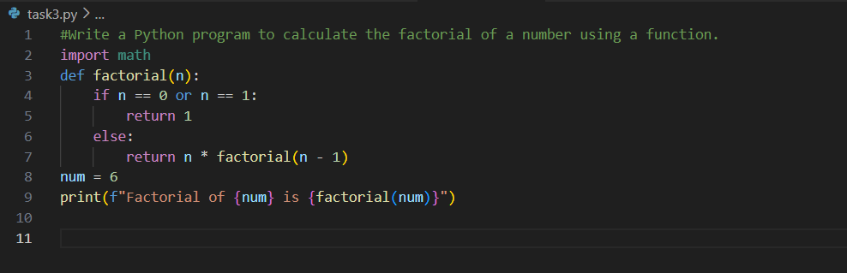

Output:-
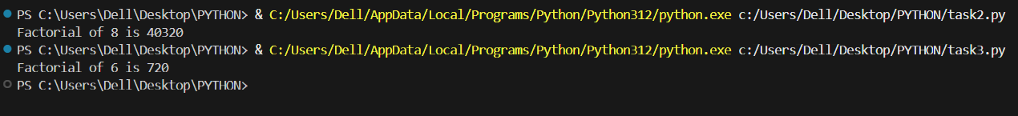

Justification:-
Using a function makes the program more structured and professional. The factorial logic is separated from the main code, which makes it reusable and easy to modify later. This is a better approach for larger programs.

Task 4: Comparative Analysis – Procedural vs Modular AI Code (With vs
Without Functions)

Prompt:-
Provide a Python function (either prime number checker or palindrome checker) and explain each line step by step in simple language suitable for a first-year student.
Code:-
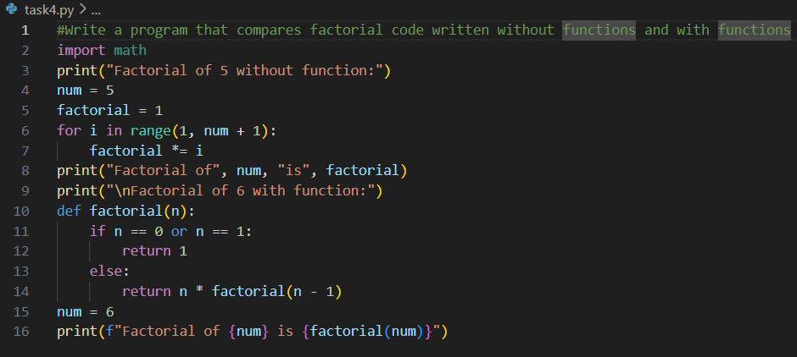

Output:-
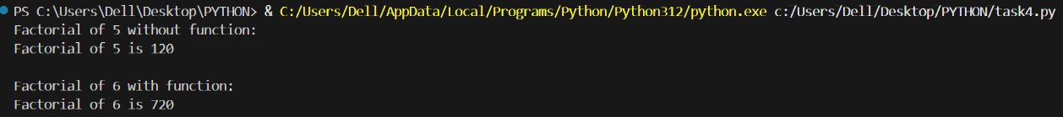

Justification:-

This comparison helps us clearly see the advantages of using functions. Code with functions is easier to understand and debug and can be reused in many places. It is more suitable for large and real-world applications than single-block code.

Task 5: AI-Generated Iterative vs Recursive Thinking

Prompt:-
Implement a Python program that computes factorial using both iterative and recursive techniques, explain the working of each method, and compare them in terms of readability, memory consumption, performance, and limitations.

Code:-
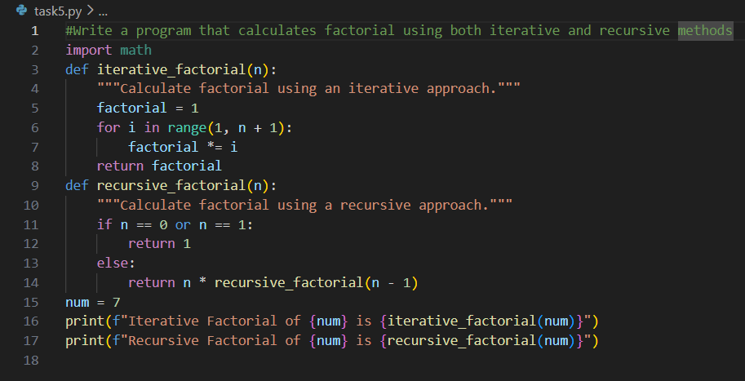

Output:-

Justification:-

This task shows two different ways of solving the same problem. The iterative method is simple and safe for large numbers, while the recursive method is easier to understand logically but can cause memory issues for big inputs. Knowing both methods helps in choosing the right solution..

